Name: Mushtaque Ali Khaskheli

Assignment: PF Lab 8

Sec: H

Task 1.a.
Input
#include<iostream>
using namespace std;
int sub(int n1,int n2);
int mul(int n1,int n2);
int div(int n1,int n2);
int rem(int n1,int n2);
int main()
{
int result,n1, n2;
cout<<"Enter a number 1: ";
cin>>n1;
cout<<"Enter a number 2: ";
cin>>n2;
cout<<endl;
result=sub(n1,n2);
cout<<"The subtraction is "<<result;
cout<<endl;
result=mul(n1,n2);
cout<<"The Multiplication is "<<result;
cout<<endl;
result=div(n1,n2);
cout<<"The Division is "<<result;
cout<<endl;
result=rem(n1,n2);
cout<<"The Remainder is "<<result;
cout<<endl;
}

int sub(int n1, int n2)
{
return n1-n2;
}

int mul(int n1, int n2)
{
return n1*n2;
}

int div(int n1, int n2)
{
return n1/n2;
}

int rem(int n1, int n2)
{
return n1%n2;
}

OUTPUT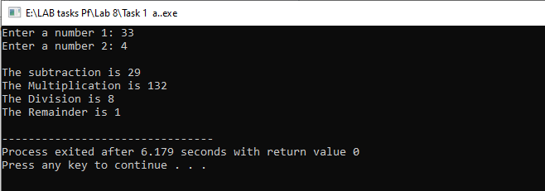
TASK 1.b
Input
#include<iostream>
using namespace std;
int square(int n);
int main()
{
int result, n;
result=square(n);
cout<<"The square of that number is "<<result;
}

int square(int n)
{
cout<<"Enter a number : ";
cin>>n;

return n*n;
}
OUTPUT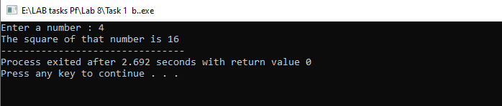

TASK 1.c
INPUT
#include<iostream>
using namespace std;
int Findgreater(int n1, int n2);
int main()
{
int num1, num2;
cout<<"Enter number 1 : ";
cin>>num1;
cout<<"Enter number 2 : ";
cin>>num2;

int result=Findgreater(num1, num2);
cout<<result<<" is greater .";
}

int Findgreater(int n1, int n2)
{
if(n1>n2)
return n1;
else
return n2;
}
OUTPUT
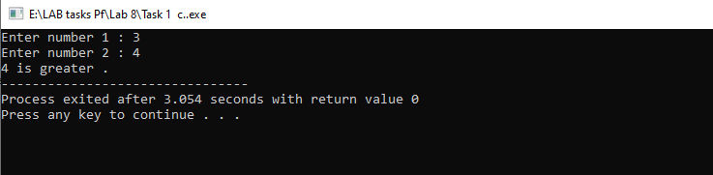
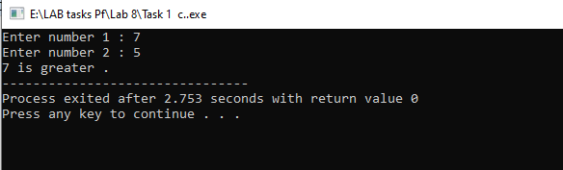

TASK 1.d
INPUT
#include<iostream>
using namespace std;
string number(int num);
int main()
{
int num;
cout<<"Enter a number : ";
cin>>num;

string result=number(num);
cout<<num<<" is "<<result<<" .";
}

string number(int num)
{
if(num%2==0)
return "Even";
else
return "Odd";
}

OUTPUT
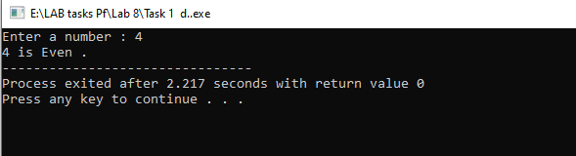
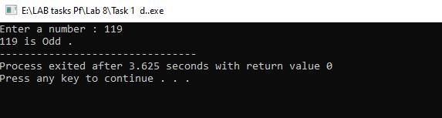

TASK 1.e
INPUT
#include<iostream>
using namespace std;
double Findpercentage(int Obmarks, int Totmarks);
int main()
{
int Obmarks, Totmarks;
cout<<"Enter Obtained Marks : ";
cin>>Obmarks;
cout<<"Enter TotMal arks : ";
cin>>Totmarks;

double per=Findpercentage(Obmarks, Totmarks);
cout<<"\nThe percentage will be "<<per<<". ";
}

double Findpercentage(int Obmarks, int Totmarks)
{
double per =Obmarks*100.0/Totmarks;

return per;
}

OUTPUT
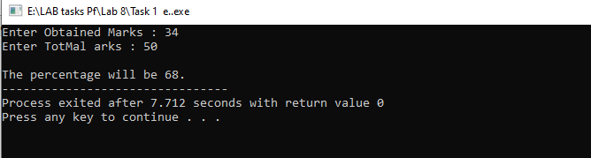

TASK 1.f
INPUT
#include<iostream>
using namespace std;
char Findgrade(double per);
int main()
{
double per;
cout<<"Enter Percentage : ";
cin>>per;
char grade=Findgrade(per);
cout<<"\nThe Grade will be "<<grade<<". ";
}

char Findgrade(double per)
{
if(per>=60&&per<70)
return 'C';
else if(per>=70&&per<80)
return 'B';
else if(per>=80&&per<=100)
return 'A';
else if(per<60)
return 'F';
}
OUTPUT
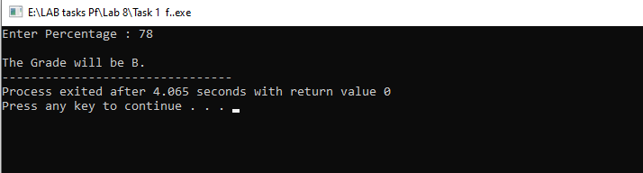

Task 1.g
Input

#include<iostream>
using namespace std;
bool FindEvenorOdd(int num);
int main()
{
double num;
cout<<"Enter a number to check whether it is even or not : ";
cin>>num;

bool check=FindEvenorOdd(num);

if(check==true)
cout<<endl<<"The number is even.";
else
cout<<endl<<"The number is NOT even. ";
}

bool FindEvenorOdd(int num)
{
if(num%2==0)
return true;
else
return false;
}

Output
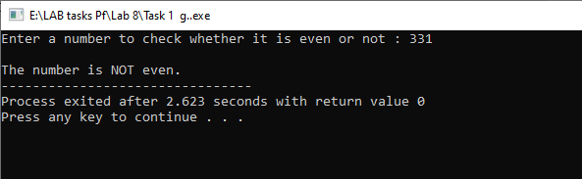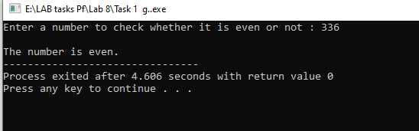

Task 1.h
Input
#include<iostream>
using namespace std;
int Findsum(int num);
int main()
{
int num;
cout<<"Enter a range upto which you want to find sum : ";
cin>>num;

int sum=Findsum(num);

cout<<endl<<"The sum of all "<<num<<" positive integers is "<<sum;
}

int Findsum(int num)
{
int sum=0;
for(int i=num; i>0;i--)
sum+=i;

return sum;
}

Output
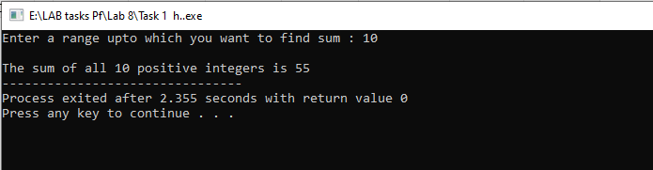

Task 1.i
Input
#include<iostream>
using namespace std;
void printTable(int number);
void printTable(int num, int Range);
int main()
{
int num, range;
cout<<"Enter any number to print table: ";
cin>>num;
printTable(num);

cout<<"\nEnter any number to print table: ";
cin>>num;
cout<<"Enter max: range for table: ";
cin>>range;
cout<<endl;
printTable(num, range);
cout<<endl;
}

void printTable(int number)
{
for(int i=1; i<=10; i++)
{
cout<<number<<" * "<<i<<" = "<<number*i<<endl;;
}
}

void printTable(int num, int range)
{
for(int i=1; i<=range; i++)
{
cout<<num<<" * "<<i<<" = "<<num*i<<endl;;
}
}

return 0;
}

Output
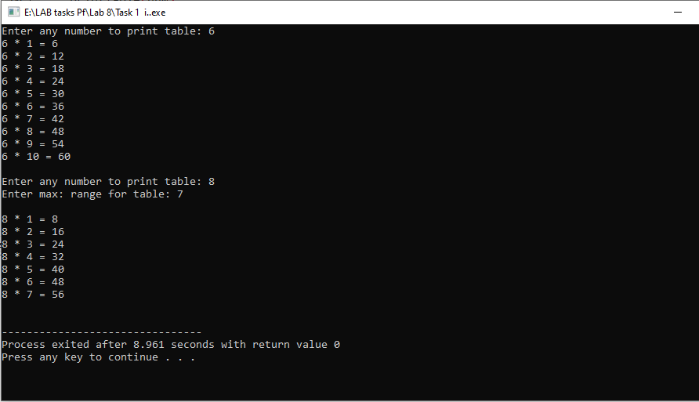

The End

